**EEE 416 Exp 2 Report**

**In addition to solving all problems in your lab sheet, please solve these problems: Prepare a PDF report. While submitting, rename your PDF file as 416_Exp2_1606XXX.pdf**

## Problem:

Write an assembly code that checks if a year is a leap year. Code template is shown below. If ‘YEAR’ is a leap year, put 1 in ‘LEAPYEAR’. Else put 0 in ‘LEAPYEAR’. You may observe value of LEAPYEAR by pressing the “var” button, beside the “flag” button

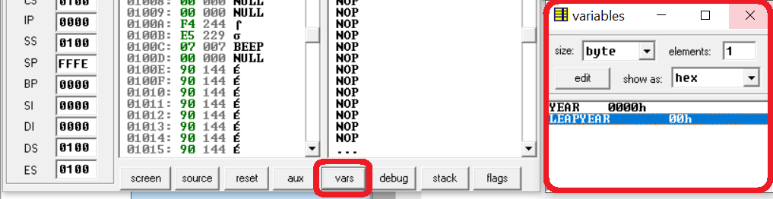

----------------------------------------------------------------------------------------------------------------------------

CODE SEGMENT

ASSUME CS:CODE, DS:CODE

MOV AX,CS ; these two lines are here to ensure DS=CS. Remember, MOV DS,CS is illegal

MOV DS,AX ; you may ignore these line in EMU. But they are necessary in Hardware

ORG 1000H

MOV AX, YEAR

MOV DX,0 ; be careful to put 0 in DX before you use DIV in case of 16 bit operand

; As DX:AX is dividend, if there is garbage value in DX, you’ll get ; specious result

;WRITE YOUR CODE HERE

HLT

ORG 1500H

YEAR DW 2021D

LEAPYEAR DB ?

CODE ENDS

END

----------------------------------------------------------------------------------------------------------------------------

## Instruction:

* Write your code, with sufficient comments to explain what you are doing
* Show Screen shot of your output [the “variables” window as shown above. show output for YEAR = 1900, 2000, 2020, 2021
* File name: 1606xxx_exp1